S/Y AXIA

Quick data:

- 124’ Ketch rig (2 masted) sailboat
- Aprox 18 years old
- Owner from Boston
- Aprox. $6 million value today
- Charters for $65,000 per week, not including fuel.

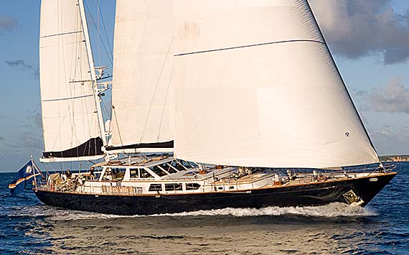

Route: Palma de Mallorca, Spain – Las Palmas. Gran Canaries Archipelago (part of Spain even though it is much closer to Morocco) – Saint Martin / Sint Maarten, Caribbean (An island that is half French and half Dutch)

Arrived Palma de Mallorca, October 8th via Midwest Connect to Newark, then via Continental to Barcelona, and finally Span Air – Barcelona to Palma

Proposed departure from Palma between October 10th – 14th ,2008

I arrived to find the boat up on jacks in dry dock or what we call “on the hard” for bottom cleaning and painting, a somewhat chaotic scene as much of the interior was still torn apart for repairs / upgrades, had been out of the water for almost a month. Jon, the skipper, asked me if I wanted to play around in Palma for a few days, or just jump right into work. Since I had been in Palma a few years ago, I really didn’t have much I wanted to do during the days, so went right to work.

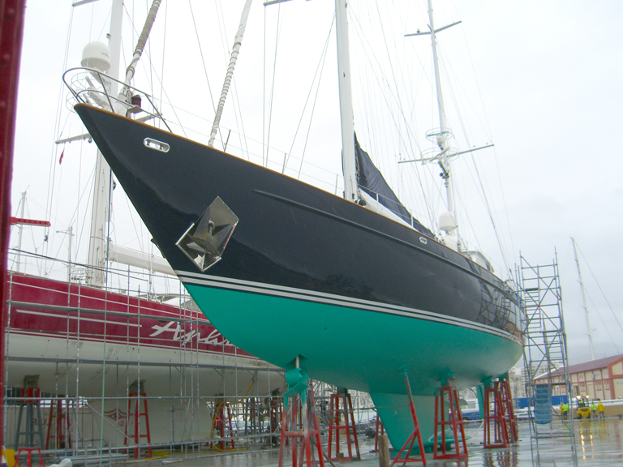

We spent 6 days working on the boat in the boat yard. The full time crew was staying at a nearby apartment in town, but I was able to sleep in the boat, so had the run of it myself during the nights. I was surrounded by some of the largest and most luxurious yachts in the world, as Palma is where many of them are based or stopover for major repairs.

These are my crew mates so far:
- Jon - Skipper – Welch (New Zealand passport) I have been sailing on and off with Jon for about 8 years. He is a very experienced and capable skipper. He just took over as skipper on Axia in June, and was previously the engineer on a famous boat called Endeavor. It is a “J” boat built and raced in the 1940s in the America’s cup. More recently, it belonged to Dennis Koslowski, the infamous CEO of Enron, who ended up in jail for fraud and general despicable behavior. Endeavor was one of his many extravagant expenditures in which he wasted the retirement monies of the Enron employees.
- Brigid Rafferty – Chef - American – Jon’s wife, a Cordon Blue trained gourmet chef, severe OCD, more about that later
- Toni Kenny – Deck hand – Dublin Ireland, all around capable and nice guy
- Brenda May Steele – Chief Stewardess - Taos & CA, sweet but overly talkative, previously a waitress in high end San Francisco restaurants
- Alex (Katherine Alexandria) Graham - Scottish, Edinburgh (textile design student) – stewardess, had worked on a few small boats before
- Me – happy to be getting paid to sail and enjoy an adventurous trip across the ocean

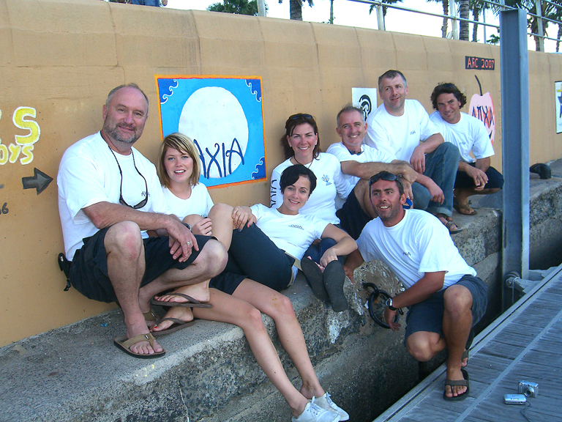

Graham Wood joins us in yard on 13th - Welsh (Bangor) mussel farmer by trade– Engineer on the boat – not full time crew, along to help out just for the delivery, another sailing friend of Jon’s that can fix anything and do about any job on any boat

I spent my days doing whatever odd jobs Jon would assign me, fixing broken hardware, doors, cabinets, lights, cleaning up behind contractors, tinkering in the engine room, preventative maintenance, deck work, sewing, patching, pretty much anything and everything. One thing I spent quite a bit of time on was custom cutting non-skid plastic covers for most of the areas we would be using during the crossing, such as galley counters, tables, sink areas. This is done so that utensils, plates, cups, food, etc. won’t slide off the counters when things are all tilted by the movement of the boat enroute. The underlying highly varnished and beautiful teak woodwork is also protected from damage by the heavy, clear, non-slip plastic. In addition, we place custom-made heavy-duty padded cloth covers on almost all the woodwork throughout the boat to protect it from damage that would certainly be caused as we move about the boat down below in rough weather.

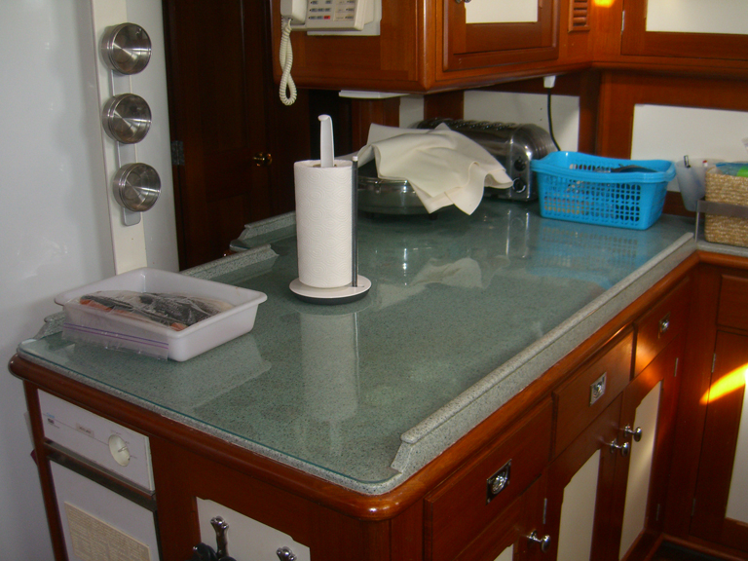

On Jon’s boats, we always sail barefoot, the entire trip, everywhere on the boat except in the engine room, as there is a grated steel floor that would chew up your feet. Barefoot helps protect the woodwork, and actually increases your traction when moving about. You would be amazed at how much traction you get with bare feet on a highly varnished wooden floor, as well as on the teak decks. Of course, there are lots of places that can get slippery when wet, as well as many toe stubbers, so you have to be careful not to break your toes. I didn’t wear shoes for about 3 weeks, and my feet are definitely not used to that. The first few days, the bottoms of my feet got very tender, but after about a week, I got my “boat feet” broken in. However, after the 3 weeks standing on hardwood and metal floors, the bottoms of both my feet went completely numb.

We worked 12-hour days getting the boat ready, but in the evenings, we enjoyed the ambiance of Palma. It is a relatively small city, with an old center section of narrow streets, quite near the marina. Every night, all the locals walk around until the wee hours, moving amongst the many tapas bars and restaurants. After tapas (basically a meal that consists of several specialty shared appetizers) we usually end up in one of the local sailor bars, hanging out with other ex-pat boat crews, most of which speak English, so able to have someone to chat with. It is relatively easy for anyone interested in working on a yacht to find a job merely by hanging out in one of the sailor pubs, or bumming around the marina. Often, if you can sign out to help out with a crossing, you will be offered a full time job on the boat by the end of the trip.

The chaos on the boat escalated as departure day approached, with lots of contractors moving on and off while we were still up on the jacks. Lots of repairs needed to be finished or re-done. They were still working on the engine, generators, air conditioning, refrigerators, freezers, interior upgrades, galley upgrades, paint, radios and more.

A couple days before we were due to get lifted back into the water, the gals made several trips to the local markets to spend about $4000 on groceries and supplies for 8 people for 18 days, this was quite a bit over our budget of 8 Euros a day per person. However, they had never shopped for a boat before, so not knowing what is and isn’t really needed, went a bit overboard, and were scolded by Brigid for this, a lesson learned. They actually shopped for two days straight, all day long, both days. We weren’t able to buy anything that needed to be refrigerated or frozen until after the boat was actually in the water, as those systems can’t be operated in dry dock.

We also ran through some emergency drills so we would be prepared for anything that might come up on the trip. We practiced starting emergency fire pumps, putting out fires with fire hoses, man-overboard procedures, a complete run through on where all the life saving and evacuation equipment is located. The boat is approved for commercial charters, so has a fairly extensive set of emergency gear.

The day before our proposed departure, we disconnected the boat from all the ground support equipment, and it was hoisted on a gigantic rolling sling gantry off the jacks and into the water. We got all the systems cranked up, and started testing them all, only to find more glitches that would need to be worked on. That would have to wait until the next day, as we had promised all the dock workers a big BBQ party after the boat was in the water, which is exactly what we did followed by a night out for ourselves. We met crews from several other boats that were also getting ready to make the crossing, and that we would run into later in the journey.

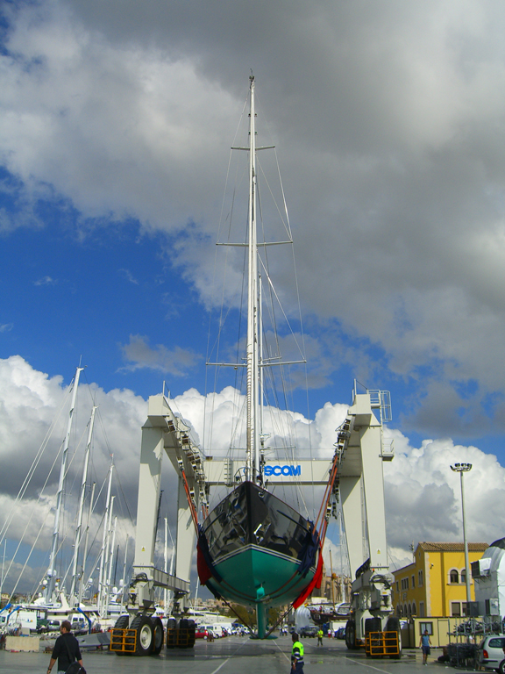

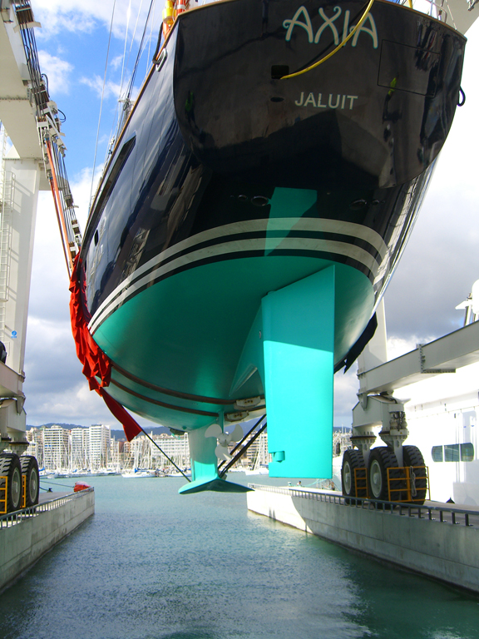

Next day, more contractors on / off, we took the boat out for a short trial run / compass check / leak test, and came back to dock where we began loading the final stores of perishable groceries, followed by filling all the fuel and water tanks. (4 water tanks and 5 fuel tanks) This took most of the day, and we realized that we still had too many unresolved issues to leave that night, so postponed till the following day. I had another trip planned to Chile following this one, and it was now looking questionable as the whether I would get back to the states in time to make the flights I had planned, so I decided to re-schedule that trip to leave a few days later. Next morning, we decided we had enough equipment working to make it safely to the Canaries, so off we went. At this point, the main engine was leaking coolant and fuel (very small leaks only), and one of our 2 large 220 volt generators did not have a working starter. We don’t really need the main engine, as we can always just sail, albeit usually slower than if we have an engine running too. However, the generator is more critical with all the electrical gear on board. We knew that if the working generator failed, we could remove the starter and swap it to the other generator to get it going. Officially departed on Oct 15th, a day later than our so-called latest day planned, but such is yachting.

Fuel data: Loaded up with 17,800 liters of fuel @ about 1 Euro per liter = about $7 per gallon
The boat uses about 5 liters per mile, about 1 ½ gallons, so about $10 per mile, trip was about 4,000 miles = $40,000 just for the fuel)

It took about 5 days to get to the Canaries, via the Straights of Gibraltar, my second time through the straights. The weather in the Med was fairly smooth, but there is usually a brown haze in the air from the sandy dust that blows up from Morocco and the Sahara. The dust covers the entire surface of the boat, so requires several daily hose downs. I was sleeping, as it was dark, as we went through the straights, so not able to see the Rock of Gibraltar. It is common to see a lot of dolphins in the Med, and we weren’t disappointed, enjoying their antics as they surfed alongside and in the waves our boat created. We ran into bigger waves as we got out into the Atlantic, and the two gals that had not done much sailing started to get a bit queasy, but managed to not get truly sick. Brenda was the most affected, and was pretty much prone the last couple days before we got to Las Palmas. She had been using “the patch” (Scopolamine), one of the best anti-seasickness medicines there is, but had taken it off after surviving the first few days, and was now paying the price for it.

The boat is due for a new set of sails, so we didn’t push the old ones very hard, instead supplementing our speed almost all the way across with the main engine. This is called “motor-sailing” when you combine sail power with engine power. Even if there isn’t enough wind for the sails to help provide any speed, just having them up helps stabilize the ride of the boat and make things a bit more enjoyable. Despite taking it easy, we still tore out one of our sails, but this is because it was near the end of its useful life anyway.

Our main engine was leaking coolant the first few days, and since we had no parts to fix it, we actually made a part (a drain plug) in case the leak got worse. We wanted to get enough wind to be able to sail at a decent speed, so we could shut down the engine long enough for it to cool down and try installing the part we made. That never happened, but the leak slowed down as we motor sailed along.

We ate like kings, thanks to having a professional gourmet chef along, who likes to dine well herself.
  - Breast of Duck
  - Veal Saltumboco (jumps in your mouth)
  - Lots of prime cuts of meat and fish
  - Home made pizzas
  - Full breakfasts if desired (breakfast fixing was on your own, no chef help)
  - Fresh salads, fruits
  - Home made soups
  - Home made bread
  - Home made pies / cakes
  - Ice cream
One new dining experience for me was “Black Pudding”, a UK favorite. Now, what sounds like a really rich, dark chocolate pudding, isn’t. Many of the things the rest of the world considers “puddings” are definitely not desert. Black Pudding is made by mixing an oatmeal type grain product with animal blood, then encasing it like a sausage. It is usually then sliced and fried for breakfast. Not as bas as it sounds, but definitely an acquired taste, right up there with Vegemite. I just smothered mine with eggs.

What we didn’t do, the entire time we were at sea was drink any alcohol, with one small exception mentioned later.

We arrived in the Canaries, a group of about 5 islands. (Gran Canaria Island, Las Palmas) just after midnight, morning of Oct 20th , and had to anchor off the main marina dock. As much as we wanted to go ashore to have a cocktail, we weren’t able to until the next morning as we could not clear through customs until they opened.

Oct 20th events in Las Palmas
- More repairs to boat
- Move to fuel dock, takes 4 hours to bunker less than ½ load of fuel
- More grocery shopping
- Ori joins crew – from Israel – normal crew boat Engineer, he spent 3 years in the Israeli navy. (we are now 3 guys sleeping in the forepeak cabin, I am in the top bunk, which is about the size of a coffin with a side door)
- Parts don’t arrive until late afternoon
- Abort PM departure, back to anchor
- I never really leave marina
- Go ashore to the “Sailor Bar” for about 1-½ hours of whiskey and internet (10:00 PM curfew imposed by Jon so we wouldn’t be too messed up the following morning)
- Alex was put in charge of painting a small mural on the cement dock wall, this is a long held tradition for all boats passing through these mid-Atlantic islands. Some consider it bad luck to not draw one. It is supposed to depict something about your boat, crew and journey. She worked a good part of the day, but we ran out of daylight before it was completed, so we all decided it was complete enough to do the job. She wanted us all to draw an item of our own into it, but we just ended up with a nice and simple job instead.

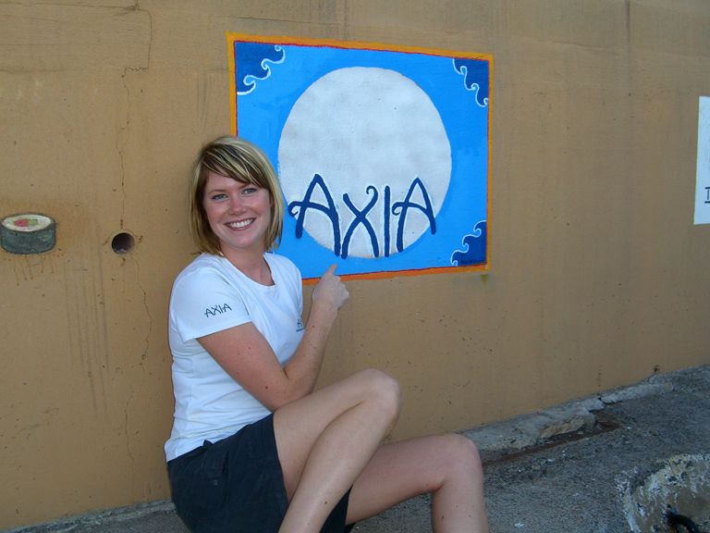
We departed Las Palmas Oct 21st AM, followed shortly by a lovely on-deck breakfast. We are planning a 12 day crossing, but may not have enough fuel to motor sail all the way, so instead of taking the most direct route straight across the Atlantic, we diverted south to try to get into an area that is known for the “trade winds”, fairly consistent winds that blow from the east to the west. That way, if we did run out of fuel, at least we would have favorable winds to help us finish the trip under sail power only. As it turned out, the fuel consumption was considerably less than planned due to having a nice slippery and clean bottom on the boat, an engine that was running better after repairs, and some help from the sails we did put up, pushing us along a bit faster than just the engine could alone. Due to the trade winds being mostly behind us all the way, it made for a rolly, polly ride, one usually least favored by sailors. The boat rocks completely from one side to the other instead of keeping a constant lean to one side as when the winds come form the side or in front of the boat. The constant rocking makes it difficult to cook, walk, and most importantly, sleep. You keep getting rolled from one side of your bunk to the other, and have to wedge yourself in as best possible, as well as adopt a relatively roll resistant posture. We call it “starfish-ing”, lying with your legs and arms all splayed out to stop the rolling. Unfortunately, my bunk was WAY too skinny to starfish, so I had to modify it to more of a snake like sleeping posture.

As we departed the Canaries, we sailed past the volcano island of Tenerife. You could see the volcano cone from about 50 miles away, it was about 12,000 feet tall. As a pilot, Tenerife holds a dubiously historic place for me, as it was the site of the worst aviation disaster in history, when 2 jumbo jets collided on a fog covered runway killing more people than any other aviation accident ever.

Boat comforts – (some covered by protection so not useable on crossing)
- Real showers (except forepeak where my cabin was located, it has a combined shower / toilet)
- Stereo in every cabin, DVD / TV in all guest cabins
- Stereo DVD / TV in crew mess
- Satellite TV – (didn’t use, too expensive at sea)
- iPod docks in galley / pilot house hooked into multiple stereo systems
- Video monitoring system
- Full laundry
- Full gourmet galley
- 2 huge freezers / fridges
- 2 more fridges in galley, fridge on deck, fridge in bar
- 2 wine fridges
- Espresso machine
- Ice maker
- Dishwasher (not useable enroute)
- Trash compactor
- Microwave
- Bar
- Library
- Salon with granite fireplace, dining table, couch
- On deck dining (3 dining areas total)
- Water toys, scuba, etc
- Pilot house to keep crew warm and dry whilst sailing
- Office for Crew w/ desktop computer
- Study for charter guests / owners
- WiFi in port (cheap)
- Satellite internet / telephones on passage (not cheap)
- Cabins for 7 crew
- All cabins have private baths – 6 total
- Guest cabins
  - Master cabin with queen bed
  - 2 guest cabins with 2 twin beds each

Boat tech:
    - 2 Radars (1 color) for collision avoidance / weather
    - 2 Primary GPS units, with supplemental GPS units integrated into other devices
    - AIS – commercial traffic transponder system that displays large boats on a computer screen
    - 2 large monitor screens – swappable to display radar / AIS / Laptop info
    - Navigation laptop with iTunes for crew / deck music
    - Autopilot integrated to steer course
    - Gyro compass
    - Flux gate compass
    - Magnetic compass
    - B&G wind / boat speed data integrated with GPS
    - Multiple VHF radio transmitters / receivers
    - Automatic VHF Distress sending system
    - Automatic HF Distress sending system
    - Automatic Satellite Distress sending system
    - Single Side Band receiver
    - Weather / hazard text printout service
    - EPIRB x 2, Emergency locator satellite beacon (sends a signal with boat name and GPS position via satellite, activate automatically if get wet and float to surface)
    - Multiple other laptops
    - Satellite dishes – at least 3
    - Intercoms / phones in every room
    - 2 electrical generators, 220 volt, powered by automotive sized diesel engines
    - 1 main engine for propulsion and electricity backup – 12 Cylinder Mercedes Benz twin-turbo diesel, aprox. 550 HP
    - 220v electrical outlets plus,110v inverters and outlets
    - 24 Volt battery bank with inverters to supply 110 & 220 volt
    - Air conditioning throughout boat
    - 2 Water makers (reverse osmosis desalination) convert ocean salt water to fresh drinkable water
    - Several hundred gallons of water tank capacity
    - Bow Thruster for maneuvering (allows skipper to swing bow of boat back and forth to help get into tight spots or to correct for wind blowing boat sideways)
    - Variable pitch propeller
    - 23 Hydraulic winches for sail control (some of the larger winches cost $80,000 each)
    - Engine room with complete work shop

Life on an angle –

Living and working on a boat like this is hard to describe, but I’ll try to give you a feeling for it. As far as boats go, this one is pretty spacious, however, it is amazing how much crap is carried and how little space there ends up available to store all that crap. Every nook and cranny ends up being stuffed full of something or other: under the floors, behind the walls, in the ceilings, under the beds, under every seat on the boat. There is so much stuff that it becomes difficult to keep track of what is stored where, especially when several different people need to know where stuff goes and get it back to the right place after usage. We actually had a computerized inventory list for every single item on the boat to keep track of just what locker or bin it was in. We carry spare parts for almost every mechanical thing on the boat, a fairly complete selection of hardware, wood, metal, and plastic bits so we can fix things enroute, spare furnishings that are only used when the owners are on board, spare cushions for every seat, extra food, extra bottled water, clothing for guests, crew uniforms in every size, tons of things like toiletries, cleaning supplies, hundreds of rolls of toilet paper, books, manuals, dishes, wine, beer, party costumes, the list is endless. When the boat departs on an ocean crossing like this one, it must be TOTALLY self sufficient for the several weeks it will take. No stopping to pick up something you forgot.

We must also be prepared for anything and everything to malfunction or quit working. If our water makers quit working, we need enough bottled water for 8 people for weeks. We would then also have to stop using water for everything we do except drinking – no laundry, no personal washing, no toilet flushing, you get the idea. If we were to lose our generators and/or engine, we would have no electricity, so the sailing would change dramatically - also no cooking, no refrigeration so our food supplies would drop quickly, no navigation instruments so we would have to go back to navigating by using a sextant and the sun, moon and stars, no hydraulic winches so the gigantic and highly loaded winches would be cranked by hand, our sails would become our only means of propulsion, so our speed would slow dramatically therefore increasing our food and water needs, no autopilot so we would all have to work harder on watch, yet we are prepared for all those possibilities.

One of the hassles of carrying all these things along with us is that almost every time you need to get your hands on something, it will be stored at the bottom of a pile or in the back of a storage bin. Additionally, everything has to be secured so that it won’t go flying about as the boat moves around on the waves. So, as you are un-securing stored items, then digging around to find what you need, you are almost always doing it with only one hand available, as the other hand has to be holding onto something solid so that YOU don’t go flying around the boat as it moves.

The movement is constant and varying. Some days are pretty smooth, you can hardly tell you’re on a boat, but most days, every move you make is governed by the waves. When on deck, you can time your movements to coincide with the pitching and rolling of the boat, as you can see the waves coming. When down below, with no outside visual reference, you have to feel and anticipate the boat’s movement before you move. Even though you may want to move across a room, you have to wait until the boat moves in a way that will allow you to move the way you want to, otherwise you just end up going nowhere, or going where you want but WAY faster than you wanted to. Moving around with a cup of coffee can get very interesting. Every doorway becomes a danger waiting for you to miss-time your movement so it can swing hard and take a finger or a toe off. Trick is to go with it, and not fight it. On a boat this size, the motion is dampened a bit compared to a smaller boat, but because the hull is longer, the motions are bigger. If you stand at the back of the boat as a fairly large wave comes by, you can suddenly find yourself moving 50 feet sideways in a matter of seconds, or dropping, almost weightlessly, over 40 feet. Some nights, as you attempt to sleep, you may also find yourself weightless, or being tossed from one side of your bunk to the other, only being held in your bunk by special boards or cloths that you attach around you. Eventually, you get exhausted enough to sleep, even through this.

Some days, if the wind is steady and we don’t change sailing angles, there will be a fairly constant tilt to everything, up to as much as 20°. Most days, there is nothing constant about it. Try to imagine living in your house after an earthquake, with everything tilted at a crazy angle. Now imagine cooking, going to the bathroom, taking a shower. Then, also imagine that the earthquake has a violent aftershock that comes and never stops, for days and days, your house rocks and rolls endlessly, and you have to go on living, cooking meals for a large family, cleaning, laundry, sleeping, home repairs, personal hygiene. Every time you open a cupboard, everything in it tries to catapult out towards you. You don’t dare lay down a sharp knife for fear it will jump off the shelf and attack you. You can never set down any kind of a vessel with fluids in it, as it will spill immediately. In the shower, you must always hold onto something, as the shower-head flow keeps changing directions as you dance around under it. Just sitting on a bench requires mild calisthenics to stay in place. Every drawer, cupboard, door, latch, hatch, cabinet, storage bin, closet, fridge, toolbox table, counter, has to be designed to stay shut and keep its contents from flying about. We use industrial strength Velcro and bungees extensively, parts of the boat look lake the space shuttle with everything Velcroed to the walls. And all of this is in fairly nice weather for the Atlantic. When it gets really rough, there is no eating, no sleeping, no nothing except hanging onto something while you try to keep the boat floating, moving, and in one piece.

On top of all that, we fight a constant battle against the damage caused by the constant motion and the elements, mostly the salt water, the wind and the sun. Any boat, no matter if it is made of steel, wood, fiberglass, or aluminum, like Axis, is in a constant state of corrosion. Even the stainless steel hardware will rust in the salty environment. So we clean, polish, rinse, scrub, scrape, wash, and wipe everything inside and outside daily, then repeat, in an effort to keep corrosion at bay. It is a losing battle though, eventually every part will corrode and need replacing, or at least re-painting. Eight people confined to a relatively small space also require a good amount of cleaning up after. For some reason, all boats seem to be hair magnets. Hair ends up everywhere, all kinds of hair ;-), and is a constant battle to keep at bay. We all pitch in to do the work. There are assigned daily tasks which generally rotate amongst all crew members, but everyone helps everyone else to do what ever it is that needs to be done, team work is the key and is practiced by all. There is still some “sexism”, as the boys generally lean towards tending to the mechanical side of things, and the gals towards the domestic, but there are many “crossovers.”

Order, as well as safety, is maintained via the watch system. There are always 2 people assigned to look after the sailing of the boat, they are the ”on” watch crew, usually one has quite a bit of sailing experience, the other not so much. On this trip, we had three sets of watch crews, working 3 hours “on” watch, followed by 6 hours “off” watch. When on watch, you pretty much stay in the pilot house portion of the boat, monitoring the course, the systems, making hourly logbook entries, and mostly watching out for other boat traffic, utilizing the radar, the AIS commercial traffic display system monitor, but mostly just using your eyes. When off watch, you can do pretty much whatever you want, sleep, read, eat, relax, watch DVDs, but you are also encouraged to do whatever work needs to be done that isn’t specifically assigned to someone else. One effect of the watch system is that you never get more than a 6 hour break, so you also never get more than about 5 hours of uninterrupted sleep, and that only happens if the waves aren’t tossing you about too much or there isn’t too much noisy activity such as hydraulic winch motors running directly above your head as the crew adjusts sails. On this trip, we had enough crew to also do what is called a “mother” watch. Every 4th day, one of four of us would take turns rotating out of the watch system, and for 24 hours, we were assigned the responsibility of doing most of the interior cleaning chores, and helping the chef prepare and clean up after meals. Even though we called it the ”mother f**ker” watch, it was actually wasn’t a very hard day, as you could sleep in, get most of the cleaning done in about 4 hours, then after dinner was served, go to bed early and catch up on more sleep. The watch assignments were also staggered, so that you weren’t always on watch with the same person, which is nice in that it allows you time to get to know all the other crew members.

It turns out, that despite spending about 3 weeks surfing across the Atlantic on a highly automated boat that requires relatively little effort to sail in the kind of weather we experienced, there is still so much work to do to keep everything running and clean, as well as everyone fed and clean, there just isn’t that much time left to relax and enjoy. There are often times, especially when working down below decks, that you can forget that you are on the boat surrounded by thousands of miles of ocean. Of course, the moment that happens, you hit a big wave, and have to once again grab on to something to avoid damage to person, and once again realize just what the environment is like outside. I ended up with about 2 hours a day of true down time: Read, wrote, played cribbage, watched DVDs, played chess, and even found some time to just watch the ocean roll past, one of my favorite things to do. Also had some amazing star-gazing on the clear nights. You truly haven’t seen the stars until you have seen them about 1500 miles from the nearest light bulb. There are times for me at sea, on a starry night, that I can forget that I am crossing the watery surface of a blue planet. Instead, it seems more like we are star travelers, slowly crossing the universe, with nothing but darkness below us and stars in front of, behind us, all around us. Just stars and space, and the feeling of movement through it as it all rotates around us.

We had wildlife encounters most of the way across, in the form of whales, dolphins, flying fish, sea birds. We always see the most sea life when near islands, and The Canaries provided many whale sightings, in fact, we had to take evasive action to narrowly miss hitting one. We were all surprised that we didn’t see more flying fish during the initial few days of the trip, but once we started seeing them, we saw lots of them. Every morning, we would find several dead ones laying about the deck that had erroneously flown onto the boat during the night.

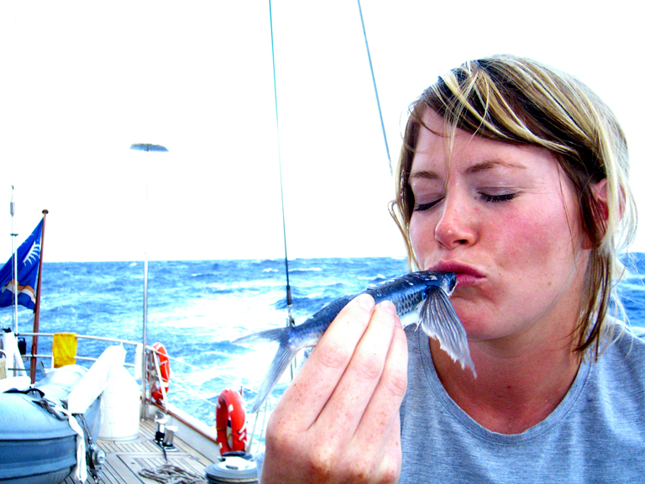

You can’t spend a couple weeks on an ocean without being impressed by it. We went about 8-½ days, traveling about 250 nautical miles per day, without seeing a single sign of human existence except our own. The volume of water on this earth is astounding. The amount of life, although rarely visible from the surface, is also astounding. “The ocean is a desert with its life underground.” (from a song by America) Too bad we aren’t giving it the respect it deserves. Almost all of the oxygen on the planet comes from the oceans (never mind the rainforests). Yet the oceans are dying , everything in them is being killed by us, the entire food chain from bottom to top. As I have said before, there are just way too many of us trying to live here.

On these trips, we always are doing some kind of fishing, trawling a line behind the boat all the way across the Atlantic. Despite this, we rarely catch anything, and the faster the boat the less likely we will. Axia was traveling at about 11 knots most of the way, so very few fish could even swim fast enough to catch the lure if they wanted to. However, we did catch a Wahoo, one of the faster fish in the sea, and made up a tray of sashimi for lunch, as well as baked filets. It was certainly some of the best sashimi I have ever had, we ate the equivalent of about $300 worth, if we had bought the same fish in an American sushi bar. We also caught a Dorado, which is an amazing bright yellow color when it first comes out of the water, but quickly drains of all its color in just a few minutes if it is killed. We hustled to get the hook out and threw it back before it died.

My birthday happened to fall on the same day we were halfway across the Atlantic, so we had a bit of a combined party to celebrate both events. We were approximately 1700 Nautical Miles from any land at this point. We dug out some pirate garb, fixed a meal of steaks and mashed potatoes, had a pirate party / dinner, followed up with a very chocolaty, airplane shaped, birthday cake in my honor, and even cracked a bottle of champagne. Sailing with Jon usually means a “dry” boat, but he was kind to us this special evening and made an exception.

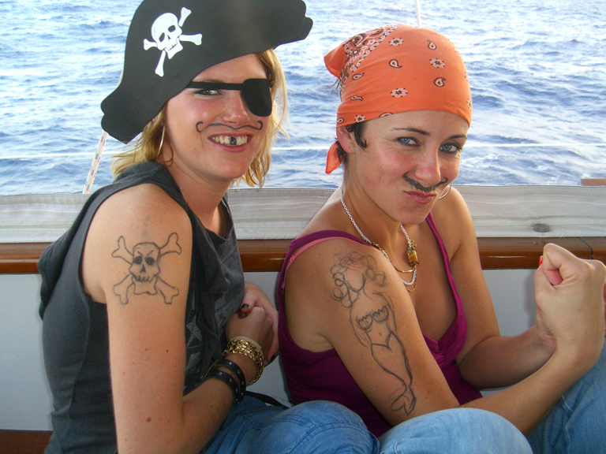
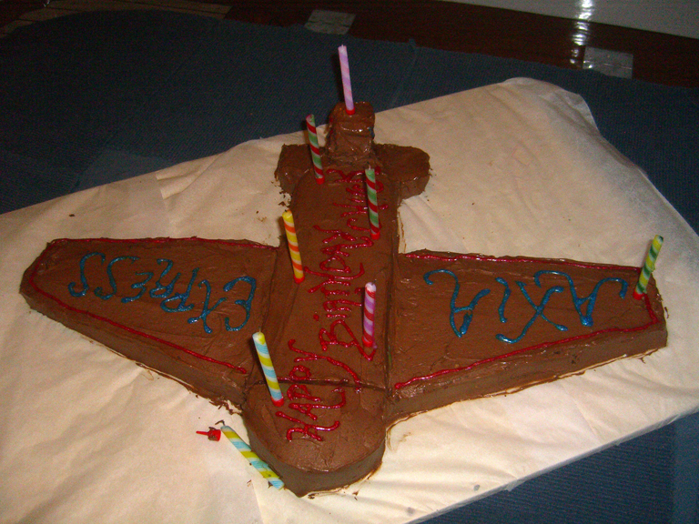

When we got within a couple days of land, everybody started to get pretty excited. The two stewardesses had never been to the Caribbean before, so were doubly stoked for our arrival. A little after midnight on Halloween night, we sailed into the bay outside the harbor and anchored for the night, as there is a drawbridge that we have to go under and it only opens 3 times a day. Once we dropped the anchor, the “dry boat” policy was lifted, and we all proceeded to make up for lost time. Every body got quite drunk, did a bit of swimming, smoked an otherwise forbidden cigarette in the dinghy, and went to bed way too late.

First thing in the morning, we went through the bridge opening, tied to a dock, then attacked the boat again with another cleaning frenzy. Boys on the outside, girls on the inside. Took pretty much the whole day to get all the salt off of everything. We ended the day with a trip to the local seaside, gourmet pizza joint, followed up with a bit of dancing at the clubs

One of the factors that had determined when we started the crossing, was the timing of the end of the hurricane season. Upon arriving in St. Martin, we heard that a hurricane had hit the island just a week or so earlier. They had a tornado and some wind damage, but no wide spread devastation.

Any time the boat is in the water, there has to be someone keeping an eye on things. So, even if we are anchored or tied to a dock, someone is on watch 24 hours a day. Jon asked me, well sort of, if I would do the 1st days 24-hour dock watch, so I just hung out on the boat while everyone else went off to enjoy the island a bit. It was actually nice to have the place to myself again, and get caught up on communications and writing. The younger ones in the crew had a HUGE night out, and as much as I would have liked to TRY to keep up with them, probably a good thing I didn’t. I made travel arrangements to jumpseat home, and was on my way the next morning. I really didn’t feel driven to explore the island at all, as it was my 5th visit there, and I needed to get back stateside to get packed for my upcoming Chile trip.

Besides, I will be back in St. Martin and the neighboring island of St. Bartholomew (St. Barth’s) at the end of March. There are a series of “gentleman’s” regattas that are geared towards these larger yachts. They all started a few years ago when some of the high $$ yacht owners in the Newport, RI yacht club were trying to decide who had the faster boat. They decided to have a race, but didn’t want to make it so competitive that anyone would be pressed hard enough to put their lovely expensive yachts in danger, nor the crews. So, they decided to make the trophy for winning the race a plain old metal bucket. It has evolved into what is called the Super Yacht series, and now has three annual races in Newport, St. Barth’s, and somewhere in the Med, usually Palma. Again, to keep it more of a casual race, it is now considered a bit uncouth to actually win the damn thing, accolades going to whoever demonstrates the spirit of having a fun and safe race, as well as to whose boat can throw the most lavish after race dockside party. With all the rich owners involved vying to out do each other’s parties, you can imagine how crazy they can get. Last year, Jimmy Buffett showed up unannounced with the Coral Reefers. Despite the “friendly” intention of the race, most owners will still usually hire professional race skippers and crew to give them an edge. This type of boat is not designed at all for racing, as it takes quite a bit of time to make course changes and get the sails set for a new course, as well as a lot of crew to do the work and prevent any damage. Fortunately, Jon was happy enough with my work on the crossing to invite me back for the race.

The morning I headed for the airport was the 1st time I had shoes on in over 3 weeks. My feet were by now so bruised and numb, that even wearing thick socks and shoes, they still hurt, and continued to for more than a month. Guess I’ll have to toughen up before my next trip.

Now, I need to say a few words about our chef / Skipper’s wife / queen of the yacht / OCD freak organizer, Brigid. Never have I known a person so compulsive about knowing and controlling each end every action of each and every person, item, thought, event, plan, and ultimately, the universe.

When each crew member arrives on the yacht, they are given a tour of the boat and the galley by Brigid. One can quickly determine just what kind of a person she is. Every item on the boat, and I mean EVERY item, is labeled, by the time you get off the boat, everything you own will somehow be identified, by a label maker label, your name sewn into your clothes, a sharpie felt pen ID, or some other coded means. Every item in the galley has one place, and one place only to be found. Although this can help with so many people accessing items, it is also impossible for mere mortals to remember where the hundreds and hundreds of items are designated to live with only a once through training session from Brigid. If you actually have to ask where something goes after the tour, you are looked at like some kind of moron. Yup, the spices are all labeled and arranged alphabetically, with all labels facing forward. (Any body remember the movie, “Sleeping with the Enemy.”) You will constantly be reminded of what you are allowed to touch and what items are off limits. We mortals are never allowed to touch such things as the good kitchen knives, or any of Brigid’s “special” kitchen gadgets. If you do something as stupid as scratch or break something, the value of it is put on a publicly displayed list of “crew” damaged items, lest we forget. Every freezer / fridge / cupboard / storage bin has been procured or manufactured to fit EXACTLY in the available space. The eggs bin must be stored under the butter bin, never vice versa. Almost every thing that Brigid asks you to do will end up being done at least 3 times, and then it will still be wrong. Now, someone needs to be in charge of keeping a boat organized, but what ended up rubbing everyone wrong, is the WAY that she asks you or tells you to do something. Never says please, just demands and orders everyone around, and treats everyone like some kind of child or dummy.

She even gets upset at Jon when he doesn’t do what she demands, even though he is supposed to be in charge. After several days of particularly unfavorable winds and waves causing the boat to roll around quite a bit, she got pissed off at Jon cause he couldn’t somehow change the weather. Now she IS an excellent cook, professionally trained, and prepared us some fabulous meals. However, most of the sailing she does is on charters where the boat spends every evening anchored in smooth waters or tied to a dock. She never has to deal with living on a boat that moves about as much as we do when we are out in the ocean. She would scold us for something as simple as spilling something on a protective cover, even though that is what they are for. She actually had us make covers to protect the protective covers !! On ocean passages, things just get spilled, can’t be avoided, but she just couldn’t except the fact that we would have to accept a little sloppiness as we got tossed about on the high seas.

For a chef on a boat, life can be more trying as the movement makes the cooking chores more troublesome. As it turns out, Brigid admitted that she hates deliveries and ocean crossings, for just this reason. The last time I sailed across the Atlantic with Jon, she did not come with us, and it made for a much happier boat, and we even managed to still keep things clean and organized. Jon was a lot more relaxed as well. By the end of the trip, we had a joke that Brigid was OCD from birth, and that when she emerged from the womb, the 1st thing she said was, “Who made this mess, and why haven’t they cleaned it up yet?”

It finally came to a head when someone left a glass in the wrong place, and it got broken. We had a big pow-wow, headed up by Jon, and were all told we were too sloppy and childish, and the “rules” would be changing. Actually, I could tell Jon didn’t want to be doing anything, and was just acting to keep his wife happy / marriage intact. By the end of the trip, we had about $50 worth of damage due to the crew breaking things. Relatively speaking, this was nothing, as I have been on trips where a LOT more damage was done, and this type of damage is considered a small price to pay when moving a large yacht across an ocean.

The night we spent on shore for the crew dinner, we had a few cocktails, and when we all got back to the boat, Brigid launched into a tirade about rumors and boat happenings that she was upset she wasn’t privy to, then started accusing us all of unspeakable (and imagined) sins. Jon finally stepped in and actually told her she was out of place. She stormed off. Next morning, no apologies, no explanations, just a strange new feeling on the boat. The rest of the crew made a big bloody-mary breakfast, and moved on. She later blamed it on “alcohol induced Turret’s Syndrome”, but no one really forgave her for it. By the following day when I left, at least three of the relatively new crew were all planning on looking for new jobs, cause they weren’t looking forward to working with her anymore. I am still trying to find a way to like her, but she sure makes it hard. Just try to focus on the good. I did mention she is a really good cook, right?

Total estimated delivery costs:
- Fuel – about $40,000
- Food – about $6,000
- Crew – about $25,000
- Expendable Supplies - $5,000
- Damage / repairs - $2,500
- And least I forget, crew damage - $50

TOTAL = $78,550 - $50 of which MAY have been avoided. (Not including the $750,000 bill for the repairs done in the boat yard before we left, and it still needs a new coat of paint above the water line)

They say that if you want to own a boat like this, to budget a MINIMUM of 10% per year of the cost of the boat to operate it. Well, that would work out to $600,000 for this boat, but that cost does not include Atlantic crossings, nor does it include unusual repairs when you buy a boat that is a bit run down. Turns out that the boat would have been worth about $10 million in top shape, so was a bargain at $ 6 mil. At least until you start adding up the cost of getting it back in top shape again so you can show off to your rich buddies in the St. Barth’s Bucket race. The boat does do some charters at $65,000 per week, so that should help out a bit too.

So for me, the old adage of the three F’s must still apply – if it flies, floats or fornicates, you’re better off renting !!

